Name_______________________
AP Psychology; Ms. Syetta

Use your DSM-5 Review packet to help you to come up with a possible diagnosis for your fictional character based on the presented symptoms.
Scar: The Lion King

Scar’s aggression towards his brother Mufasa goes far deeper than simple sibling rivalry; it stems from the deep rooted symptoms of his disorder. Scar has utter disregard for the violation of the rights of others. He doesn’t think twice about luring Simba into a trap that would kill him or throwing his brother off the cliff to his death.

Scar is also fiercely devoted to his own thirst for power. He might be aware of the destructive force of his power struggles on those around him but it doesn’t matter to him. As for his tyrannical leadership of the hyena population; Scar is arrogant and demanding and he expects everyone to follow his every whim, something that becomes apparent when he replaces his dead brother as king of the pride.

In The Lion King, Scar simply didn’t care about the wide-spread damage caused to the pride lands; if anything he was proud of the death and devastation, although a distorted view of action and consequence meant he didn’t have the foresight to see that this would lead to a lack of food supply. A king, Scar, most definitely does not make.

Symptoms:

Possible Diagnosis:

Name____________________
AP Psychology; Ms. Syetta

Use your DSM-5 Review packet to help you to come up with a possible diagnosis for your fictional character based on the presented symptoms.

Captain Hook-Peter Pan
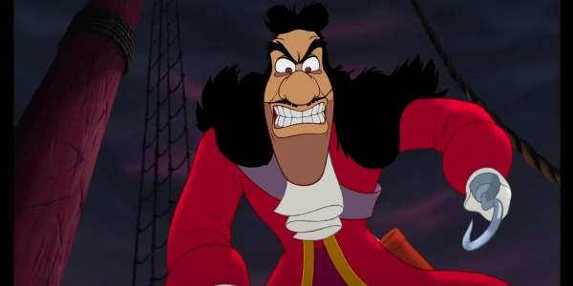

Poor Captain Hook; most of his issues can stem back to the horrific incident that occurred where Peter Pan chopped off his hand and fed it to a crocodile. In fact, given those tragic events, is it any wonder that he continues to lash out at Peter and his own crew in a desperate effort to maintain some measure of control?

What’s even worse is that this crocodile continues to hunt poor Hook. With the alarm clock in its belly its presence is always accompanied by a tick-toking, sending the captain into blind panic. It’s a perpetual state of terror as he relives that terrible event. It isn’t just the crocodile that causes him to break; any ticking clock will inflict the trauma. It’s the disorder that prevents him from breaking the vicious cycle he has found himself in; hunting Peter Pan, desperate to exact revenge. He should be doing what any good pirate captain would do and set sail across the sea in search of plunder.

His trauma reaches a breaking point at the end of Peter Pan, where he loses his boat and is chased by the vicious crocodile across the sea.

Symptoms:

Possible Diagnosis:

Name____________________
AP Psychology; Ms. Syetta

Use your DSM-5 Review packet to help you to come up with a possible diagnosis for your fictional character based on the presented symptoms.

Elsa-Frozen

Elsa’s powers can cause a very real threat to the people around her, so much so that you could argue that her paranoia early in the film is fully justified. That being said, the two powerful events in her childhood; almost killing her sister Anna and the death of her parents at sea, are the triggers of her disorder. The young princess shuts herself away, refusing even to see her sister in the years leading up to her coronation.

That event is an obvious sign of distress for Elsa; she spends the ceremony and the celebration afterwards in a state of half-panic. Shutting herself away seems the only solution available to protect Anna and her subjects and as a result, her powers almost destroy her.

When Elsa plunges the kingdom of Arendelle into its deepest winter, she flees, but as soon as she is isolated from everyone she returns to her old habits, creating the ice palace and shutting herself inside. It is only when Anna shows her that their sibling love is greater than any threat that she finally breaks the cycle, realizing that in gaining acceptance from her people that she doesn’t need to hide away any longer.

Symptoms:

Possible Diagnosis:

Name____________________
AP Psychology; Ms. Syetta

Use your DSM-5 Review packet to help you to come up with a possible diagnosis for your fictional character based on the presented symptoms.

Ariel-The Little Mermaid
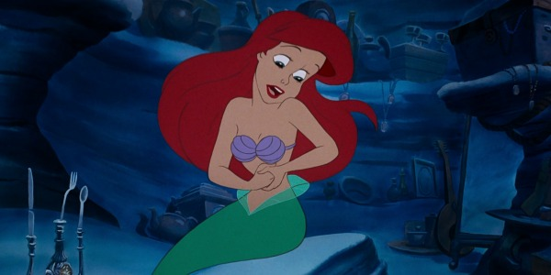

Rather than live the life of a princess in the royal court of the King Trident, Ariel spends her time stealing treasures from the ship wrecks of poor men and women lost at sea. This rebellious teenager does not know what it is to clean up her room and can’t throw anything away. Her cavern is overflowing with things that she has no clue how to use and she can’t part with them.

“I’ve got gadgets and gizmos a-plenty.

I’ve got whozits and whatzits galore.

You want thingamabobs? I’ve got twenty!

But who cares?

No big deal.

I want more!”

But thieving from the dead is the least of Ariel’s issues. She believes her body is defective and needs to be “fixed” in order for her to be whole again. It’s for this reasons she becomes fixated on humans, and Eric in particular. She goes as far as to indulge black magic to fix herself, ridding herself of her tail fin in favor of legs. She’s a human trapped in a mermaid’s body and she goes to extreme measures to correct herself.

Symptoms:

Possible Diagnosis:

Name____________________
AP Psychology; Ms. Syetta

Use your DSM-5 Review packet to help you to come up with a possible diagnosis for your fictional character based on the presented symptoms.
Dora-Dora the Explorer

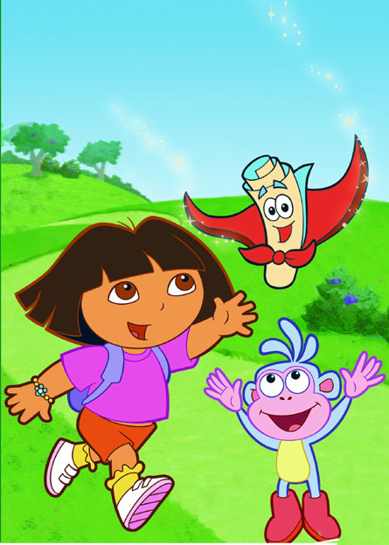

Dora seems like a child with a healthy personality, right? She seems to have a good relationship with her parents and extended family, is social with many animals and other people, and has an expansive thirst for adventure. It seems like she’s living the dream of every preschooler. She is able to wander off and around her world until she find an adventure, without having to worry about anything beyond her inability to recall previous travels.

She temporarily forgets memories or her own personality for a period of time, but will eventually recover with all previous memories whole.

Sounds a bit like a soap opera. However, how this applies to Dora is by her incessant wanderings. These episodes often result in unplanned trips, none of which are remembered later on. You think that, with all these adventures she has, Dora might not have to consult the map as often as she does. If she’s forgetting these episodes thought, it makes more sense.

Symptoms:

Possible Diagnosis:

Name____________________
AP Psychology; Ms. Syetta

Use your DSM-5 Review packet to help you to come up with a possible diagnosis for your fictional character based on the presented symptoms.

Eeyore-Winnie The Pooh

Eeyore consistently insists that his tail falls off rather frequently. Eeyore’s posture typically involves a lumped head, droopy eyes and commonly says “thanks for noticing me.” Sluggish movement is also apparent without any physical cause for movement delay. He seems to step on his tail often and fall down. Eeyore indicates that sometimes it seems that even his close friends do not need him. Around friends, he typically makes comments about his relative unimportance and travels near the back of the pack. He also stated that although he tries to force a smile, a real smile has not existed in a long time, even though others try to cheer him up. He often feels empty even when accompanied by friends. Eeyore also seems to experience a loss of energy throughout the day, although sleeping habits are not explicitly discussed.

Symptoms:

Possible Diagnosis:

Answers
Scar: Anti-Social, Narcissistic Personality disorder
Captain Hook: Post traumatic stress disorder
Elsa-Frozen: Agoraphobia
Ariel: Hoarding, Body dysmorphic disorder
Dora: Dissociative Amnesia
Eeyore: Major Depressive Disorder

